

Vendor Guide
Hachette Book Group
Packing, Labeling, Shipping Requirements

______________________________________________________________________________

The purpose of this guide is to provide instructions for packing, labeling and shipping products that you manufacture for Hachette Book Group and its distribution clients to our Lebanon, IN warehouse. All shipments must comply with these instructions. Non-compliance may result in charge backs.

These specifications are effective immediately.

Please always note any exceptions to these instructions on the purchase order.

For assistance in interpreting these instructions, please direct queries to Raymond Kennedy via email to Raymond.Kennedy@hbgusa.com or call him at 212-364-1384.

WAREHOUSE ADDRESS

Hachette Book Group
123 North Enterprise Blvd
Lebanon, IN, 46052

ROUTING AND DELIVERY APPOINTMENTS

DOMESTIC SHIPMENTS

TRANSPORTATION
Please call ECHO toll-free at 1-877-439-3343 when product is ready for pick-up. Contacts are Heather and Colleen. Please call 24 hours in advance of pick-up.

DELIVERY APPOINTMENTS
Product will not be received without a delivery appointment. Please contact HBG Receiving Department to arrange a delivery appointment. Appointments can be made Monday – Friday on non-holidays.

Email indyinbound@hbgusa.com
Tel: 765.483.8625
Delivery Scheduling Hours: 7am – 3:30pm CT
Receiving Hours: 7am – 3:30pm CT

All appointments must be made 24 hours in advance of delivery. The following information is required to obtain a delivery appointment:

- Shipper Company Name
- Purchase Order Number(s) / Bind Order Number(s)
- ISBN Numbers / SKU
- Quantity Per ISBN / SKU
- Number of Pallets and/or Cartons
- PRO / BOL Number
- Total Weight
- Trailer Number
- Seal Number

Receiving personnel will validate the quantity and preliminary condition of the goods received and request the driver or delivery personnel to sign the Bill of Lading acknowledging delivery of goods including any notation of shortages, overages, refusals, and or damages to products delivered. Please be aware that concealed damages or shortages that are found at a time after the receiving process will be communicated to the Vendor and charged back accordingly. Please also be aware that Inbound Appointments will be managed stringently and that chargebacks may be assessed if a carrier does not schedule an appointment and/or is late.

IMPORT SHIPMENTS

FOB SHIPMENTS
Please notify Tandem Global Logistics one week prior to ship date.

CH Powell
830 Dillon Rd
Wood Dale, IL, 60191
Attn.: Tom Were
Tel: 630-860-8507
Email: tbwerre@chpowell.com

The documents listed below with required information must be sent to Tandem:

- Bill of Lading / Proforma Invoice
- Title
- Quantity
- ISBN
- Carton Weight
- Carton Dimensions
- Number of Books per Carton
- Total Weight of Shipment
- Packing List

CIF SHIPMENTS
It is the responsibility of the shipper to provide HBG with all documents necessary to transfer the shipment from the shipping company and for its clearance through US Customs.

The following documents with the required information must be sent to:

CH Powell
830 Dillon Rd
Wood Dale, IL, 60191
Attn.: Tom Were
Email: tbwerre@chpowell.com

- Shipping Advise with ETA
- Insurance Certificate
- Packing List
- Bill of Lading
- Certificate of Origin
- Commercial Invoice

IMPORTER SECURITY FILING
The shipper needs to supply HBG & its agent the necessary data elements to enable HBG and its agent to complete ISF filing with US customer 48 hours prior to loading on the vessel. See Appendix A at the end of this document for the Import Security Filing Data form and instructions.

C-TPAT (Customs-Trade Partnership Against Terrorism)
HBG is a certified C-TPAT (Customs-Trade Partnership Against Terrorism) company and expects all of the suppliers to meet the recommendations/guidelines of the program. The C-TPAT program is a voluntary Government-Industry program designed to increase security at our borders.
If you are an overseas bindery, you will be required to complete HBG C-TPAT Security Questionnaire. Please contact our Transportation Manager to obtain this form and to answer any questions you may have related to HBG’s participation in the program.
For additional information, please visit the below link to CBP (US Customs & Border Patrol): http://www.cbp.gov/xp/cgov/import/commercial_enforcement/ctpat/

All FOB arrangements (port of Chicago, IL) are to be made by Tandem Logistics.
*see Tandem list below

All cartons should be loaded on pallets in the container when shipped from overseas.

AIRFREIGHTING INSTRUCTIONS
Air Freighting shipments must first be approved in writing by HBG. Once approved, the printer must provide the following information to Raymond Kennedy for proper routing instructions:

- ISBN
- Title
- PO Number
- Print Quantity
- Bound Book Date
- Carton Pack
- Carton Weight

HACHETTE BOOK GROUP OVERSEAS FORWARDING AGENTS

BELGIUM
Tandem Global Logistics Netherlands BV
Vlaardingweg 63 - 3044 CJ Rotterdam
P.O.Box 11140 - 3004 EC Rotterdam
The Netherlands
Tel: +31 (0)10 240 48 89
Fax: +31 (0)10 240 48 99
Contact: Dan Bakala
Email: dbakala@tandemgloballogistics.nl

FRANCE
Centrimex
33, bd de l’Europe
ZI Les Estroublans
13127 Vitrolles
Tel: 33 (4) 4.42.15.98.74
Fax: 33 (4) 6.50.31.38.72
Contact: Ms. Aude Petit
Email: a.petit@centrimex.com

GERMANY
Rieck Sea Air Cargo Gmbh
Kolumbusstrasse 14
D-22113 Hamburg
Germany
Tel: 49-40-7812422
Fax: 49-40-7812433
Contact: Frank Rottmann
Email:
Frottmann@Hh.Rieck-Logistik.de

HONG KONG
Tandem Global Logistics (HK) Ltd
Room 2005-2006, 20/F Orient International Tower
1018 Tai Nan W Street
Cheung Sha Wan,
Kowloon, Hong Kong
Tel: 852-27416018
Tel: 852-93484428
Fax: 852-27424280
Contact: Sharon Lee
Email: Slee@Tandemgloballogistics.hk
Email: agnesng@tandemgloballogistics.hk

ITALY
Iscotrans
Via Alla Porta Degli Archi, 3
16121 Genova
Italy
Tel: 39-010-5729911
Fax: 39-010-541453
Contact: Ms. Laure Mazzoli
Email: L.Mazzoli@Ge.Iscotrans.it

JAPAN
Tandem Global Logistics Group
Azuma Shipping Co Ltd Int’l Transp
Shuwa-Sakurabashi Building
4-5-4 Hatchobori, Chuo-Ku Tokyo 104
Tel: 81-03-3206-5681
Fax: 81-03-3206-1277
Contact: Mr. T. Sakurai
Email: Toshi@Azumaship.Co.jp and Rbreukel@Tandemgloballogistics.com

KOREA
Woojin Global Logistics Co., LTD
RM801,Gangseo Hanwha Bizmetro 1st Building
551-17 Yangcheonro, Gangseo-gu,Seoul, Korea
Tel: (82-2)-3706-3434
Fax : (82-2)-6280-5706
Contact: Joanne Cheon
Emil: joanne@woojingl.com

MAYLASIA
KGW Logistics (M) SDN BHF – Petaling Jaya (HQ)
D11-10-1, Block D11
Dana 1 Commercial Center
Jalan PJU 1A/46
Ara Damansara
Petaling Jaya, Selangor
Malaysia
47301
Tel: +603 7842 8899
Fax: +603 7842 9899

Contacts:
Dato’ Roger Wong, General Manager
Tel: +6012 781 7199
Email: roger@kgwlogistics.com

Hui Yen
Tel: +6012 222 76
Email: huiyen@kgwlogistics.com

NETHERLANDS
Tandem Global Logistics
Lorentzweg 6
3208 Li Spijkenisse
Netherlands
Tel: 31-(0) 181-601161
Fax: 31-(0) 181-601179
Contact: Joep Stijns/ Ron Breukel
Jstijns@Tandemgloballogistics.com

SINGAPORE
UEI Logistics (S) PTE LTD - Singapore
7030 Ang Mo Kio Avenue 5
Singapore
569880
Tel +65 6886 1515
Fax +65 6570 0605

Contact:
Ng Soh Cheng, Sales Manager, sohcheng.ng@uei.com.sg
Terrence Tan,terrence.tan@uei.com.sg

SPAIN
Grupo Tracosa
Ocean Deparment
Avda. Paralelo, 15 2º
08004 Barcleona
Tel: (34) 934 439 830 – Ext. 27
Mobile: (34) 610 137 498
Contact: Adrián Karmi
Email: karmi@tracosa.com

TAIWAN
Realco Logistics Ltd
4th floor, no. 10, Lane 345
Yangkuang Street
Neihu District
114713, Taipei, R.O.C.
Tel: 886-2-87973330 – ext. 260
Fax: 886-2-26596634
Contact: Alison Shih
Email: alisonshih.tpe@realcolog.com

THAILAND
Tandem Global Logistics
A division of Siam Azuma Multi Trans Co., Ltd
Tel: (66) 2 238-5303-6 Ext. 401
Fax: (66) 2 237-6279, 2 238-5308
Contact: RaitreeW
Email: ratree@azuma.co.th
UNITED KINGDOM
Ocean Global Line
91 Gainsborough Road
Felixstowe, Suffolk, IP11 7HR
Tel: +44 1394-279549
Fax: +44 1394-285281
Contact: Mr. Keith Smith
Email: Keith@She-Fxt.com

U.S.A
C.H.Powell dba Tandem Global Logistics
1263 N. Wood Dale Road
Wood Dale, Il, 60191
Tel: 630-860-1703
Fax: 630-860-1723
Contact: Kris Osewski
Email: Klosewski@Tandemgloballogistics.com

CARTONS

CARTON PACKING & CLOSURE
- Books must be packed lying flat, with each book in a stack in the opposite orientation.
- Books must never be packed vertically standing.
- Special dispensation can be made for cartons containing novelty and book+ titles, however, approval from HBG will be required prior to shipping. Please contact the buyer well in-advance of packing.
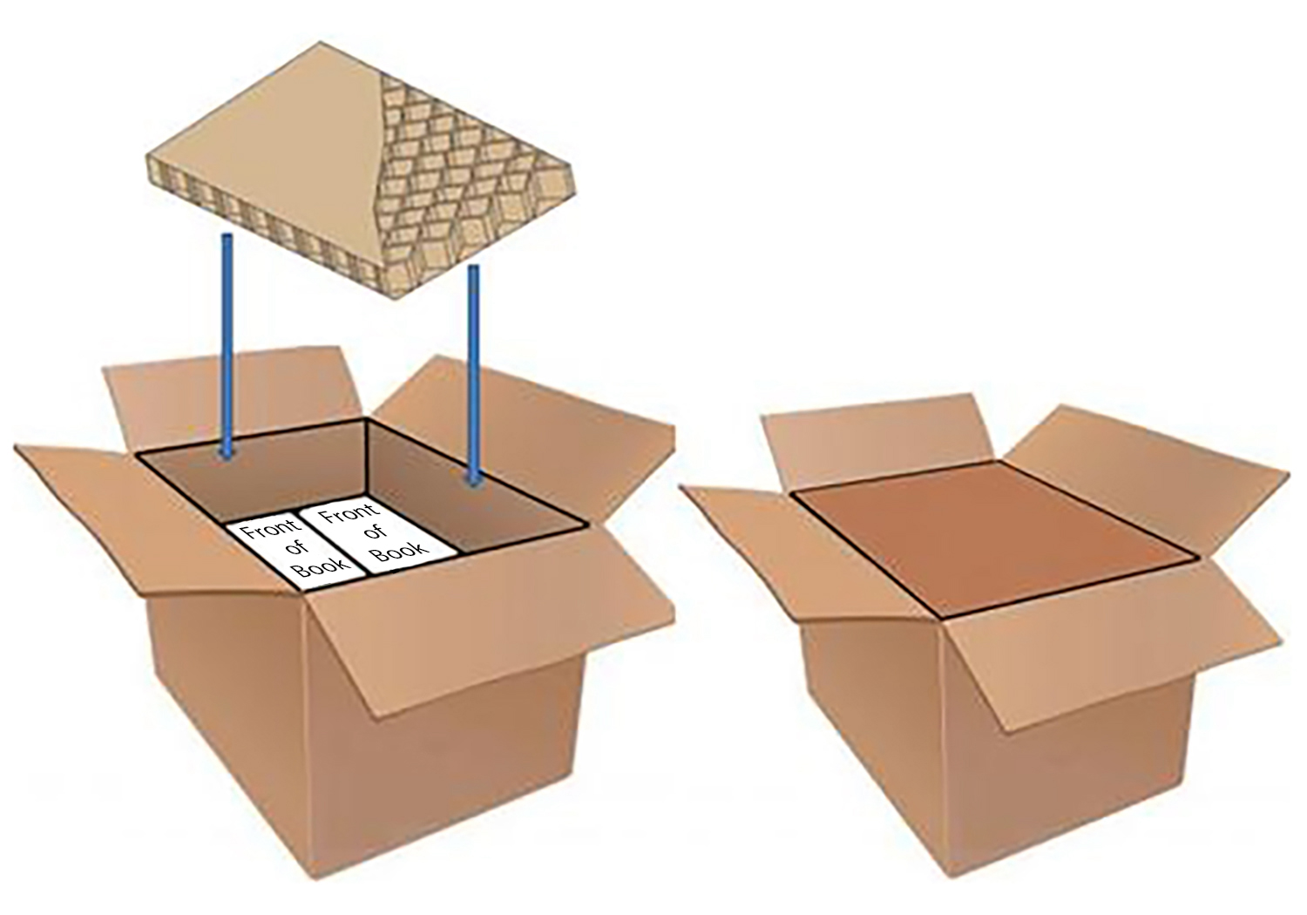

- Stacked books should not be wrapped in brown paper or shrink-wrapped inside the carton.
- The carton should be designed to fit the books without any spaces after filler is applied.
- Cartons must be packed tightly and filled to minimize horizontal movement during shipping and handling. There should be no more than a maximum of 1/8” (3.175mm) on all sides of the carton, between the book stack and the carton side.
- All open space must be adequately filled, preferably with flat corrugated filler sheets or honeycomb cardboard to avoid damage to the books.
- No more than 1” (25.4mm) of filler may be used at the top of cartons.
- The use of packing peanuts, air bags, and shredded paper is prohibited.
- Cartons should be taped closed my machine, using a minimum 2” or wider tape. The gauge of the tape should be no less than 2mm thick. The tape should be clear or beige adhesive and not the reinforced paper.
- Cartons must not be individually banded.

PARTIAL CARTONS
Hachette Book Group does not accept delivery of partial cartons. Cartons containing less than full carton quantities will be destroyed. Payment will not be made to vendor for partial cartons received. The only exception may be to “digital short run” or POD books. Vendors manufacturing should look for special dispensation on the purchase order or contact the buyer for special dispensation if it has not been provided.

CARTON SPECIFICATIONS
- Carton size, quantity, and weight for any title should remain consistent from first printing through all reprints of the title, provided that no material changes have been made to the book.
- Any changes to carton size, weight, or quantity due to material change to the book should be conveyed to the buyer as soon as the change is evident. (i.e. We should NOT be discovering the change upon receipt at the warehouse.)
- Gross carton weight may not exceed 42 lbs.

DOMESTIC SHIPMENTS

DIMENSION | MINIMUM | MAXIMUM
Height (inches) | 3” | 18”
Length (inches) | 9” | 21”
Width (inches) | 7” | 21”

Maximum Weight = 42 lbs.
The carton should have a minimum 200 pound bursting strength ‘C’ flute and/or, have an ECT (edge crush test) equivalent of 32 lbs. If the ECT 32 box is used, it must have the same side impact protection as the 200 pound bursting strength ‘C’ flute carton.

IMPORT SHIPMENTS

DIMENSION | MINIMUM |  | MAXIMUM
 | Inches | Millimeters | Inches | Millimeters
Height (inches) | 3” | 76.2mm | 18” | 457.2mm
Length (inches) | 9” | 228.6mm | 21” | 533.4mm
Width (inches) | 7” | 177.8mm | 21” | 533.4mm
Maximum Weight = 42 lbs.
The carton should have a minimum 275 pound bursting strength ‘C’ flute and/or, have an ECT (edge crush test) equivalent of 32 lbs. If the ECT 32 box is used, it must have the same side impact protection as the 275 pound bursting strength ‘C’ flute carton.

OVERSIZED and/or UNUSUALLY HEAVY BOOKS
On occasion, an oversized or unusually heavy weight book will require the use of a heavier weight carton to provide additional support during transit. Arrangements and cost implications should be discussed with the buyer during development of these titles.

CARTON LABELS
Each carton must be labeled in accordance with the Book Industry Study Group Guidelines for Shipping Container Labeling. This document can be accessed at https://cdn.ymaws.com/bisg.org/resource/resmgr/Files/Publications/Labels_and_Barcodes/shipping_label_guidelines.pdf

Title Author
ISBN Publisher
Carton quantity Carton weight
US & Canadian retail price Purchase Order Number
Printing Number Country of Origin
On-Sale Date

Zone 3
Zone 2
Zone 1
4”
6”

Further details can be found on P.40 of the PDF in the BISG link provided above or in Appendix B at the end of this document.

PRODUCT LABEL REQUIREMENTS
The product label is required on all cartons. The marking may not be stenciled on the carton. The purchase/bind order will provide instructions on the product information that should be on the carton label. This information will be noted in the special instructions box. Any additional marking is prohibited without prior approval.

LAYOUT
- Label cartons beginning at the bottom RIGHT on two sides (i.e. one end and one side).
- Wrap around labels are acceptable. If applying wrap around labels to cartons, place the label so that one half is on the long side of the carton on the bottom RIGHT, and the other half is on the short end of the carton on the bottom left.
- Black ink should be used for print.
- The label should not be printed closer than 1.25 inches from any edge of the carton.
- All bar codes must have a minimum height of 0.5 inches, however it is highly preferred that a height of 0.75 inches is used.
- In order to support high speed scanning, use a minimum dimension of 0.015 inches (15 mils).
- There must be a “quiet zone” or white space of at least 0.25 inches following the bar-code.
- The recommended minimum label width is 6”, and the minimum label height is 4 inches.
- ISBN must be a minimum of .25 inches or 25 point font.
- Human Readable ISBN
- We highly recommend that carton label is certified by BISG.
Go to this link to view the BISG guidelines - https://cdn.ymaws.com/bisg.org/resource/resmgr/Files/Publications/Labels_and_Barcodes/shipping_label_guidelines.pdf

ZONES
The product label information should appear in the zoned layout defined below in the listed sequence. All bar codes must follow the UCC/EAN-128 symbology and technical specifications as defined in this document.

Zone 1- Product Information: Human Readable
Title
Author
Publisher
On-Sale Date This field is only to be included on first printing titles. All dates should be in MM/CC/YY format.
Country of Origin

Zone 2- Publisher Information: Human Readable and/or Bar Coded
Publisher Purchase Order Number (Human readable and Bar Coded)
Cover Four Bar Code Designation (Human readable)
EAN, UPC, or E/U if the title has both an EAN and UPC
Printing Number – Printing number – Year of printing (Human readable and Bar Coded)

Zone 3- Product Information: Human Readable and Bar Coded
Carton Quantity
ISBN 13: ISBN 13 should be the only ISBN printed on the carton label
Carton Weight
Cover Price (US/CAD)

Note on Bar Coding the ISBN in Zone 3:
While the human readable ISBN 13 is to be printed to the right of the barcode on the Product Label, it must be encoded in the bar code as a 14-digit identifier utilizing GS1-128(UCC/EAN-128) symbology. This identifier, also known as GTIN 14(14-digit Global Trade Item Number), includes the Application identifier “01” and a fixed prefix of ‘1’ that is required and is used when you will need to recalculate the check digit.

Calculating the GTIN-14
To figure out the calculations for encoding the IBSN in GTIN-14 format please refer to the The Book Industry Study Group(BISG) website page 54 Appendix E: Calculations.
https://cdn.ymaws.com/bisg.org/resource/resmgr/Files/Publications/Labels_and_Barcodes/shipping_label_guidelines.pdf
Or you can go to this website and enter the correct numbers and have it calculated for you. https://www.barcode.graphics/check-digit-calculator/

Using the check digit calculator on this website, go down to the GTIN-14 and enter the number as follows:
Using the ISBN below of 978-1-234-56789-7 as an example.
Prefix the ISBN with ‘1’ (package level indicator indicating a standard case pack), then drop the original
check digit of ‘7’ (the last digit) and enter into the first box 1 978 123456789 and hit the “Calculate” button.
Your new check digit is 4 and the GTIN-14 is 19781234567894.

Further explanation and instructions can be found on P.54 of the PDF in the BISG link provided above or in Appendix C at the end of this document.

Carton Label Approvals
If necessary, Carton Labels can be sent to Virginia Marsh (Virginia.Marsh@hbgusa.com) or Compliance@hbgusa.com for approval.
Be aware that label approvals may take up to 3 business days.
In order for labels to be approved, HBG requires a sample label in PDF format (Excel if necessary), that is fully populated.

***Hachette Book Group does not approve label content, only format.
Vendors are responsible for ensuring label content is correct based on the provided purchase order.***

PALLETS

- Use only 48” x 40” four-way entry Standard GMA pallets (see diagram.)
- Corner Boards, wooden tops, pallet straps and empty spacer boxes are NOT to be utilized.
- Cartons must not overhang pallet.
- Each pallet must be as close to a maximum height of 52” from floor as possible.
- The gross pallet weight must not exceed 2200 lbs.
- Cartons must be secured tightly in clear shrink wrap and be connected to the pallet itself with minimum 80-gauge film to avoid shifting of cartons during transit.
- Cartons should be stacked on a pallet in an alternating pattern or should be interlocking (brick stacked) with a consistent number of cartons per pallet, in a way that maximizes the number of cartons per pallet.
- Cartons should never be straight stacked.
- Once the number of cartons and books per pallets is established for a title on a 48 x 40 pallet, that profile should remain for that first printing and all subsequent printings.
- Titles and printings must never be mixed on one pallet.

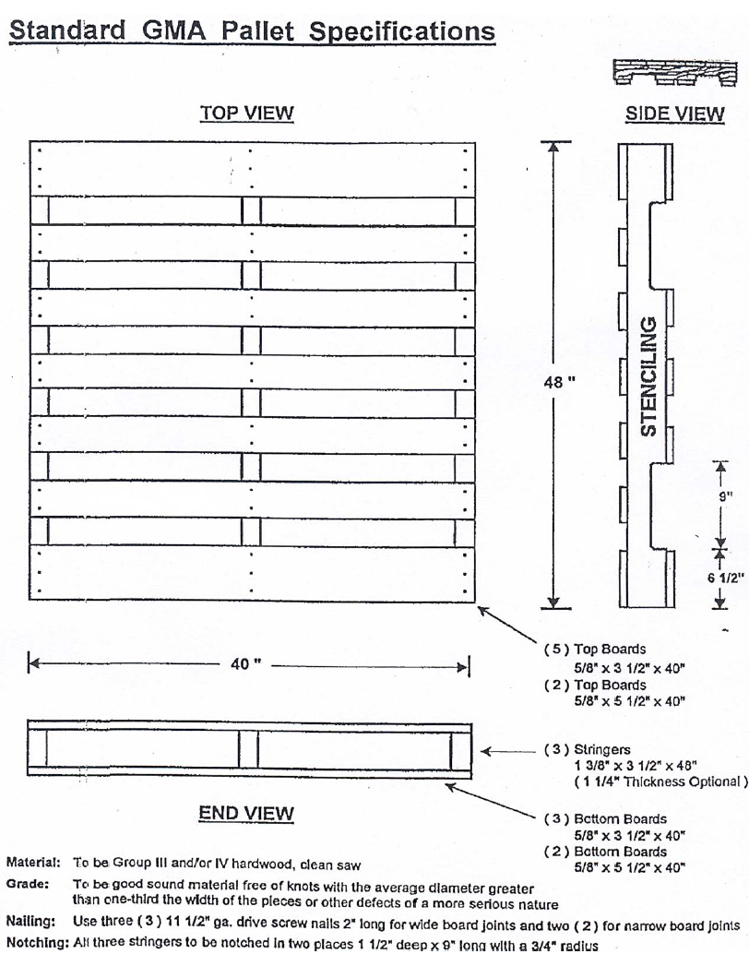

Advanced Shipping Notifications (ASN)

EDI requirements
EDI Capable Vendors must provide ASN Documents via Standard inbound 856 and 945 transaction set.

To obtain EDI Capability
If you are an EDI capable partner and would like to set up a protocol with us, please contact hbg-editechsupport@hbgusa.com to establish specific EDI documents and the EDI communications link, from testing to production.

DOCUMENTATION

Packing List
A packing list detailing all information must accompany each shipment and should be indicated in a prominent manner to the Receiving Department.
The necessary details are as follows for each title shipped:
- ISBN 13
- Price
- Title
- Total carton count
- Number of books per carton
- Total quantity shipped
- PO number
- Total pallet count
- Carrier

In the event that an exception or change is made, flag the change in the paperwork. All exceptions must first be approved by HBG through the buyer.

If more than one title/printing is being sent on a truck, the packing list should indicate how many pallets there are for each title/printing.

Note: Titles and Printings cannot be mixed on a pallet.

Cartons containing the packing list must be clearly marked “Packing List Enclosed”.
Only one title per carton is acceptable.
Packing lists must be faxed or emailed to delivery appointment contact prior to shipment arrival.

Bill of Lading Requirements
Printers must follow the Voluntary Interindustry Commerce Solutions (VICS) standard format for all bills of lading. http://www.vics.org/guidelines/bol/

Freight Terms
All BOL for HBG (not clients) products must be clearly marked as follows:
PREPAID - Third Party Billing
Hachette Book Group
1290 Avenue of the Americas
New York, NY, 10104
Attn.: Raymond Kennedy

All BOL for Distribution Clients (NON-HBG product) should be marked for billing according to the specific Client’s instructions on the Purchase Order that was provided. DO NOT USE THE 3RD PARTY BILLING ADDRESS ABOVE.

Shipper & Consignee Information – for HBG prepaid shipments

Shipper
Your company name
Address
City, State Zip

Consignee Information
Hachette Book Group
121 North Enterprise
Lebanon, IN, 46052

Shipment Information
- Actual carton count and number of pallets
- HBG Purchase order number(s)

Two copies of the bill of lading should be given to the carrier at the time of shipment. Carrier is to retain one copy for his files and attach the second copy to the freight bill.
Inbound freight bills without a bill of lading copy attached will be sent back to the carrier.

The carrier should be instructed that all shipments must have delivery appointments.
Imports - All copies of all Bill of Ladings, Packing List and Invoices must be faxed or emailed in advance.

If you have questions on routing the shipments, please contact Raymond Kennedy.

DIRECT CUSTOMER DELIVERIES
Direct deliveries are shipments that deliver directly to our customers (all shipments consigned to destinations other than the HBG’s Lebanon Warehouse).

NO shipments may be made to a customer without an approval from HBG.

Upon completion of the order, the following bill of lading information must be faxed or emailed to DemandManagement@hbgusa.com and the buyer. This communication must occur on the same day as the shipment.

For PREPAID shipments - Mark the BOL with the notation “Bill All Freight Charges” to: Hachette Book Group
1290 Avenue of the Americas
New York, NY, 10104
Attn.: Raymond Kennedy

For COLLECT shipments the BOL should be marked COLLECT and reference the customer’s 3rd party billing address.

All drop shipments should be packed on 48” x 40” refurbished GMA pallets, unless specifically noted otherwise for special customer requests.

Bindery must adhere to the customer’s Vendor Guidelines, if applicable.

Failure to comply with timely notification or any of the above requirements can result in substantial compliance charges.

HBG CONTACTS

TRANSPORTATION – Carrier Issues, Routing, Bindery Shipment Transportation & Deliveries
Raymond Kennedy
Executive Director, Transportation & Logistics
Hachette Book Group
1290 Avenue of the Americas
New York, NY, 10104
Tel: 212.364.1384
Email: Raymond.Kennedy@hbgusa.com

ASN Transmission Inquiries
HBG EDI at hbg-editechsupport@hbgusa.com

Non-EDI ASN Testing & Approval
HBG EDI at hbg-editechsupport@hbgusa.com

General Queries
Raymond Kennedy
Executive Director, Transportation & Logistics
Hachette Book Group
1290 Avenue of the Americas
New York, NY, 10104
Tel: 212.364.1384
Email: Raymond.Kennedy@hbgusa.com

C-TPAT Questions
Raymond Kennedy
Executive Director, Transportation & Logistics
Hachette Book Group
1290 Avenue of the Americas
New York, NY, 10104
Tel: 212.364.1384
Email: Raymond.Kennedy@hbgusa.com

Customer & Client Inquiries
Terry Tamm
Manager, Customer & Client Services
Hachette Book Group
Boston, MA
Tel: 617-263-2813
Email: Terry.Tamm@hbgusa.com

Brittany Ganzak
Executive Director, Customer & Client Services
Hachette Book Group
Boston, MA
Tel: 617-263-2920
Email: Brittany.Ganzak@hbgusa.com

Ann Nucci
Manager, Demand Management
Hachette Book Group
Boston, MA
Tel: 617-263-2803
Email: Ann.Nucci@hbgusa.com

HBG Main Telephone number 800.759.0190

Distribution Center – Lebanon, IN
COO Distribution Michael Shoults 765-805-4370
Executive Director, Operations Matt Busenbarrick 765-483-8616
Inbound Manager Adam Middleton 765-483-8694

APPENDIX A

IMPORTER SECURITY FILING DATA
Importers to the United States are required to submit an importer security filing below to Customs and Border Protection no later than 24 hours before cargo is laden aboard a vessel destined to the United States. C.H. Powell requires the data 72 hours before cargo is laden.
Instructions:
1 | Seller – last known entity to whom the goods are sold; if no sale than name and address of the owner
2 | Buyer – last known entity to whom the goods are sold; otherwise the owner
3 | Importer of record – The importer of record IRS or EIN number.
4 | Consignee IRS number – EIN or IRS number of the ultimate consignee
5 | AMS Bill of lading number at the lowest level (house bill of lading) SCAC required also
6 | Manufacturer/supplier – the name and address of the last entity that manufactures, assembles, produces or grows the commodity. If not known use the supplier of the finished goods in the country from which the goods are leaving.
7 | Ship to – The first deliver to party that receives the goods after release from Customs.
8 | Country or origin – The country of manufacture, production or growth, based upon the laws, rules and regulations of the U.S.A.
9 | HTS number – The HTS number to the sixth digit. May be reported to the US 10 digit number.
10 | Container stuffing – the physical location where the goods are stuffed.
11 | Consolidator – the party who stuffed the container or arranged for its stuffing
12 | Estimated sailing - Vessel Departure date

 | 
  
IMPORTER SECURITY FILING DATA
 | Mandatory
1 | Seller name and address
2 | Buyer name and address
3 | Importer of record
5 | AMS HOUSE Bill of Lading number and SCAC Code
 | Mandatory - Can be amended prior to vessel arrival
6 | Manufacturer/supplier name and address
7 | Ship to name and address
8 | Country of origin
9 | Commodity HTSUS number
 | Mandatory - 24 hours to vessel arrival
10 | Container stuffing location
11 | Consolidator (stuffer) name and address
 | Tracking information
 | Container number(s) and pieces
1 | Carrier
2 | Vessel Name and Voyage Number
3 | Loading date
4 | Sailing date
5 | Arrival date / port of discharge
6 | Booking number
7 | PO/commercial invoice number
Supplier provides info in RED
Forwarder provides info in BLUE
APPENDIX B

APPENDIX C

Updates

12/09/19 Freight Forward contact detail updated for Singapore.
06/27/23 Freight Forward contact detail updated for Singapore and Malaysia.
Replaced Jo Coe with Ann Nucci.
07/24/23 Added Freight forwarder contact detail for Thailand and Korea.
12/09/24 Added more clarity to the orientation of books in a carton.

