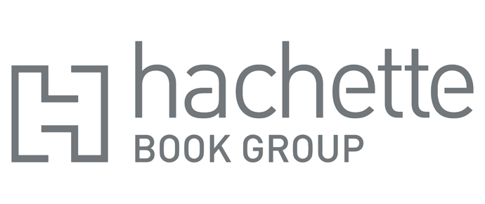
Hachette Post Holiday Buy 2 Get 1 Free Select Titles Promotion-Canadian Version
Retail accounts may claim a credit for each title sold or given away as part of this Buy 2, Get 1 Free promotion from Hachette Book Group as specified below. The giveaway title must be of equal or lesser value to the two books purchased. Accounts may run this promotion for a maximum of seven weeks beginning on December 26th 2022. In order to qualify for this credit, physical retailers must promote the title in a designated store location, and the promotional offer must be called out on the books themselves or with signage indicating the new sale price. Internet retailers must feature the books prominently on their corporate retail homepage as part of a Buy 2, Get 1 Free promotion for a maximum of seven weeks beginning December 26th 2022 to participate in this offer. This offer is open to all accounts that purchased on a returnable basis directly from HBG, or via a wholesaler, who would like to participate in this offer.
Retailers are, of course, free to charge whatever price they choose, but only those meeting the above terms will qualify for the credit. This promotion supersedes any previous offer on these titles.
EAN/ISBN-13 | Title | Pub Date | CAN Retail | Funding Per Unit $
9780316003957 | MYSTERIOUS BENEDICT SOCIETY | 3/27/2008 | $ 12.99 | $ (2.17)
9780316201568 | LAND OF STORIES WISHING WELL | 6/25/2013 | $ 12.99 | $ (2.17)
9780316204972 | LOKIS WOLVES BLACKWELL 1 | 4/2/2014 | $ 12.99 | $ (2.17)
9780316456548 | CUPHEAD 1 CARNIVAL CHAOS | 3/3/2020 | $ 19.99 | $ (3.33)
9780316540087 | DAUGHTER OF SPARTA | 5/17/2022 | $ 14.99 | $ (2.50)
9780316551670 | HUNTING PRINCE DRACULA | 8/21/2018 | $ 14.99 | $ (2.50)
9780316551724 | ESCAPING FROM HOUDINI | 8/12/2019 | $ 14.99 | $ (2.50)
9780316334419 | HELLO GOODBYE AND EVERYTHING | 4/29/2016 | $ 14.99 | $ (2.50)
9780316273183 | FROSTBLOOD SAGA 1 | 7/17/2017 | $ 15.99 | $ (2.67)
9780316485517 | CAPTURING THE DEVIL | 7/10/2020 | $ 14.99 | $ (2.50)
9780316273336 | FIREBLOOD FROSTBLOOD | 4/13/2018 | $ 14.99 | $ (2.50)
9780316273367 | NIGHTBLOOD FROSTBLOOD | 5/17/2019 | $ 14.99 | $ (2.50)

In order to be eligible, the retailer must furnish to its Hachette Book Group sales representative, or to our sales department, proof of its retail sales for the promotional period. Proof and claim must be received by the Hachette Book Group no later than 3/30/23. Deductions for anticipated credits will not be honored. Credit will be issued after review of proof of sales.
Our suggested retail price will remain as originally cataloged, and returns on any copies will be credited based on the cataloged retail price and the terms of our returns policy. If a retailer purchased copies from a wholesaler, the retailer must furnish us with evidence of that purchase to receive direct credit from us. However, if a retailer who purchased copies from a wholesaler does not want to receive its credit from the Hachette Book Group directly, the retailer can make arrangements with the wholesaler to have credit issued to the wholesaler for the retailer’s account, and we will honor the wholesaler’s submission to that credit to the wholesaler’s account.
For more information, please contact your Hachette Book Group sales representative or Hachette Book Group, 1290 Avenue of the Americas, New York, NY 10104.

